Kindly make credential at <https://console.cloud.google.com/>  
And add project   
Then go to **Credentials**

and add **OAuth 2.0 Client IDs**In them we give **Authorized redirect URIs**

as <https://developers.google.com/oauthplayground>  
  
And save it   
  
  
Then go to this uri in the right side click gear icon   
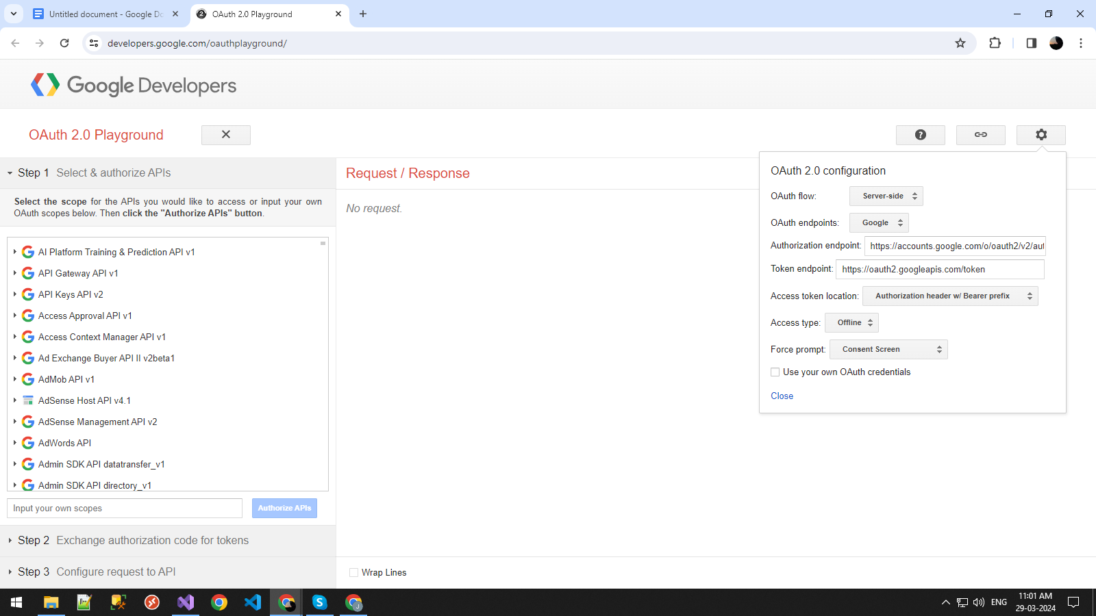

Then check the checkbox and you get this page  
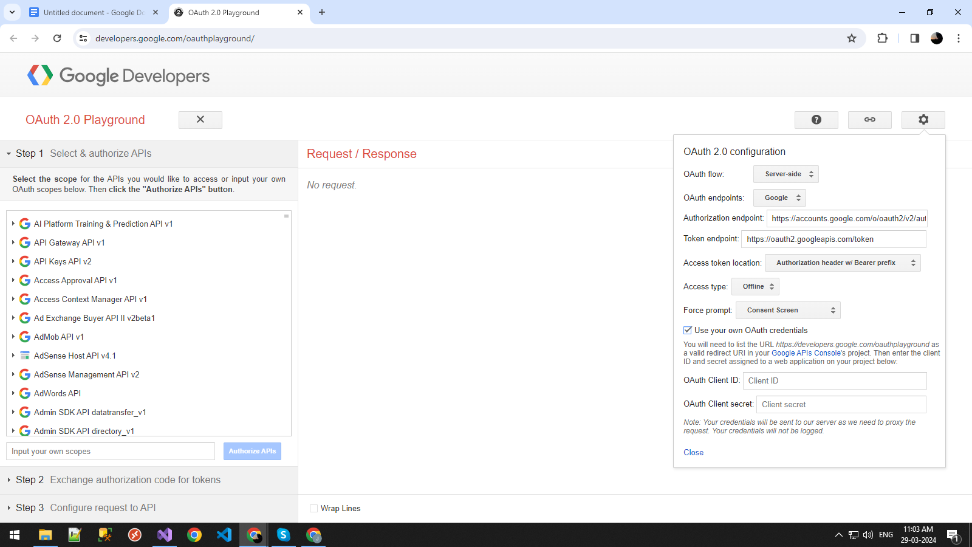  
  
Then add client Id and secret on them and then close it  
  
After that   
In step 1  
You have to select Gmail API v1 in them select [*https://mail.google.com/*](https://mail.google.com/) And click Authorize api  
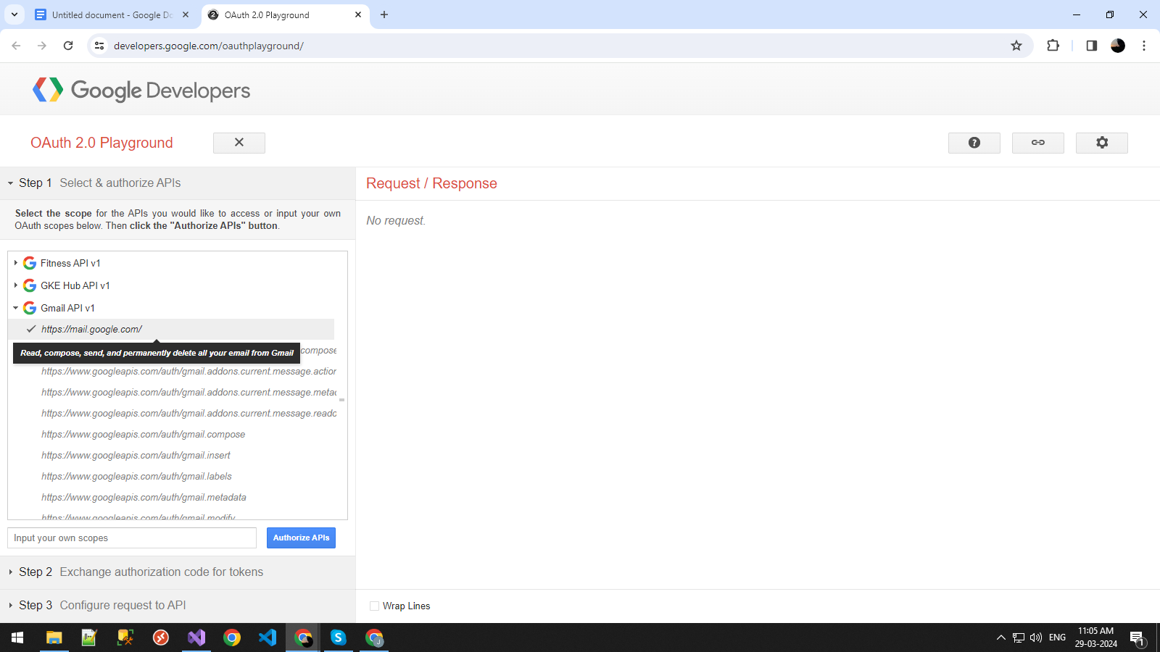

Then allow access  
Then you are going to step 2  
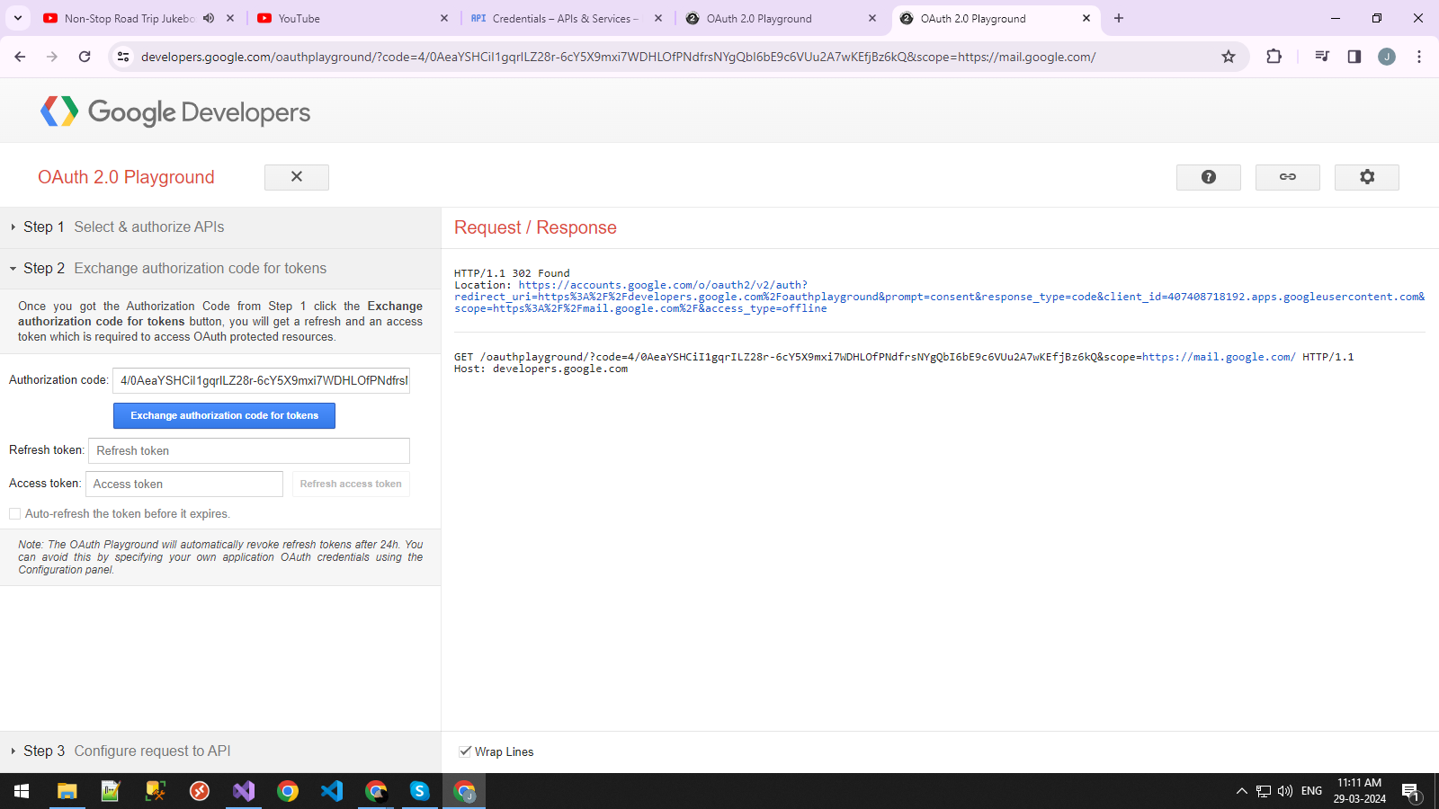

After that first check the Auto-refresh the token before it expires. Checkbox then click button



And you get refresh token  
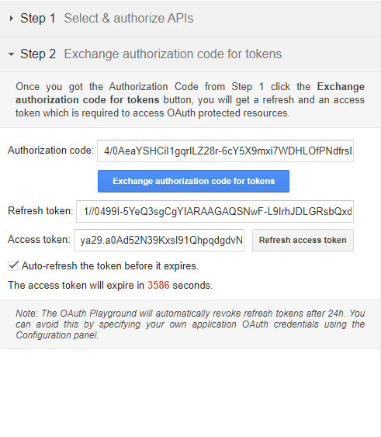  
  
  
Kindly copy it and add it on GmailServiceHelper class  
  
  
That's it  
  
Thanking you